WALT WHITMAN

- Create a Timeline with at least 10 significant events from Whitman's life.
2. Write a brief description of Whitman's admiration for President Lincoln.

3. Read the poem “O Captain! My Captain!

Poem: "O Captain! My Cptain!" - Whitman pays tribute to President Lincoln.

Brief Analysis: "O Captain! My Captain!" is a lyric poem (a poem that attempts to express a strong feeling). Whitman uses the following poetic devices to express his grief at the death of Abraham Lincoln, the captain of the ship (of sstate), was killed before he could enjoy the ending of the war:

- apostrophe - the poem's speaker addresses a dead captain (Lincoln) in the style of an ode.
- repetition - phrases such as "heart! heart! heart!" and the repeating of "fallen cold and dead" emphasize the poet's grief.
- word choice - even in the lines that describe the victory celebration, the use of doleful phrases cast a gloomy shadow.
- extended metaphor - the poem is an extended metaphor with Lincoln as the captain and father, a term which deepens the reader's sadness.

3.1 Provide the definition of a lyric poem and discuss what feelings the poem's speaker attempts to express. Define apostrophe, repetition, metaphor, ode.

4. Read the poem “I Hear America Singing”

Poem: "I Hear America Singing" - Whitman pays tribute to the people who make America great--its workers.

4.1 Do a choral reading of “I Hear America Singing.” Write what stood out to you as you read the poem aloud in one voice.

4.2 What does Walt Whitman mean by “singing”? Why do the people in his poem “sing”?

4. 3 Discuss Whitman's description of the different workers in the poem.

Industries of California
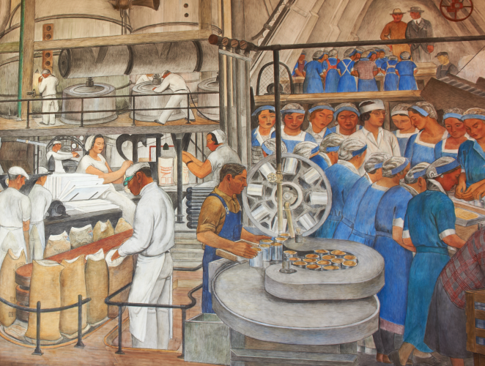

Brief Analysis - Singing is a metaphor for the goods and services produced by American workers. Whether you consider it a Marxist cry for the workers of the world to unite or a celebration of the Capitalistic notion that each man's work is his own is open to interpretaion (I lean to the latter). America is an example of synechdoche, with the whole representing the parts.

